**DIPRO - Biopolymer-free drill-in fluid system enhances drilling while simplifying completion.**

**KAZAKHSTAN**

**ONSHORE**

**Background**

Operator required a cost-effective water-based drilling fluid to drill several water injection wells.

Customer concerns were related to:

* Formation damage
* High solids content at high density
* High possibility of mud losses during drilling operation
* Filter cake removal
* Recovery of full formation permeability

Kaz M-I recommended Operator to utilize DIPRO divalent brine-based reservoir Frill-in Fluid. Fluid contains high density brines and low concentrations of Calcium Carbonate.

**Technology**

DIPRO water-based drilling fluid system

**TECH REPORT**

**JOB DETAILS**

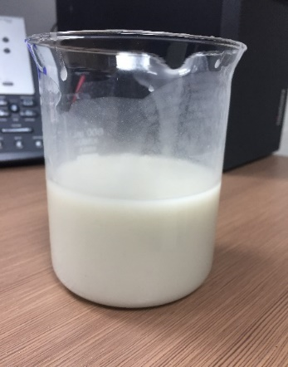

|  |  |  |  |  |
| --- | --- | --- | --- | --- |
| Well depth: | 903 m |  | Max LGS, % | <5 |
| Starting Date | 16-Oct-19 |  | Achieved | 2.2 |
| Ending Date | 23-Oct-19 |  | MBT, ppb | <5 |
| Completion | 10 days |  | Achieved | 2 |
| Days Programmed | 14 |  | API FL, ml/30 min | <5 |
| Days Actual | 8 |  | Achieved | 1.5 |

**The reservoir section was successfully drilled with DIPRO RDF mud system. The sand control screens were run to desired depth without any problems and the reservoir section was gravel packed. The DIPRO fluid system met performance expectations during drilling and completion.**